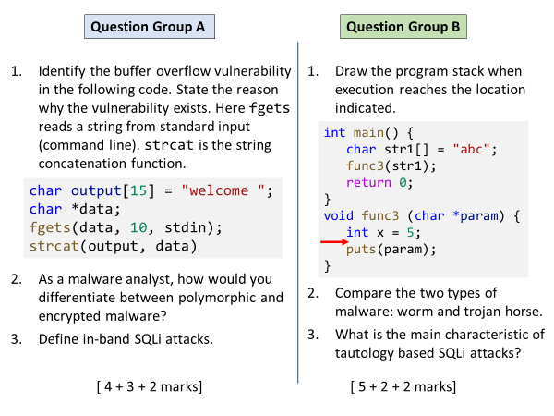
Group A
Q1
output array has capcity of 15 chars, initially 9 occupied (including null terminator). data string could be be at most 10 characters (including null). So their concatenation can create a string of 18 characters, which exceeds capacity. Hence strcat() call is vulnerable.
For full marks, they need a precise analysis like above.
Q2
Encrypted malware encrypts its body with a random key and places a decryption routine at the start. Multiple samples of encrypted malware will all have a common code (decryptor) at the start, hence a signature can be recorded for easy identification.
Polymorphic malware is actually an encrypted malware, except that the decryption routine is differently mutated for each sample so that creating a signature is much more harder.
Q3
To send the injected SQL code to database server, attacker uses the same path as used by typical user inputs.

Group B
Q1
↑
Stack growing backwards
x = 5
old frame pointer
func3 return address
address of str1
a
b
c
null
They can also draw it inverted, growing downwards. Order of the items inserted is important.
Q2
Worms exist standalone, auto injected into victim systems due to security vulnerabilities
Trojans are disguised inside apparently useful programs. Require user action to get into a target system.
Q3
Attacker’s SQL contains a condition that always evaluates to true, causing extra data to be leaked in query results.

